**Calculating family expenses using service now**

Team ID : NM2025TMID20043

Team Size : 4

Team Leader : THEJASHWINI.T

Team member : AISHWARYA.S

Team member : GAYATHRI.M

Team member : NITHYASHREE.N

**MILESTONE:1**

**ACTIVITY 1:Setting up ServiceNow Instance**

**1.Sign up for a developer account on the ServiceNow Developer site** [**https://developer.servicenow.com**](https://developer.servicenow.com)**.**

**2.Once logged in, navigate to the “Personal Developer Instance” section.**

**3.Click on “Request Instance” to create a new ServiceNow instance.**

**4.Fill out the required information and submit the request.**

**5.You’ll receive an email with the instance details once it’s ready.**

**6.Log in to your ServiceNow instance using the provided credentials.**

**7.Now you will navigate to the** ServiceNow

**MILESTON:2**

**ACTIVITY 1:Creation of New Update Set**

**1.Go to All >> In the filter search for Local Update set > click on New.**

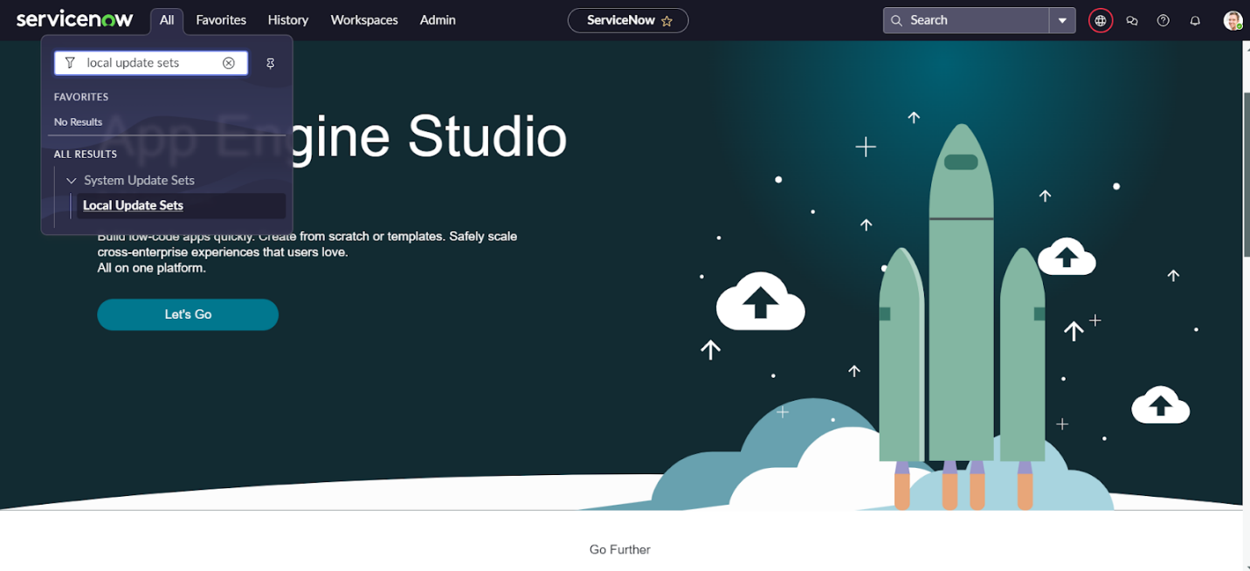

1. Enter the Details as:

Name : Family Expenses

1. Then click on Submit and Make current.

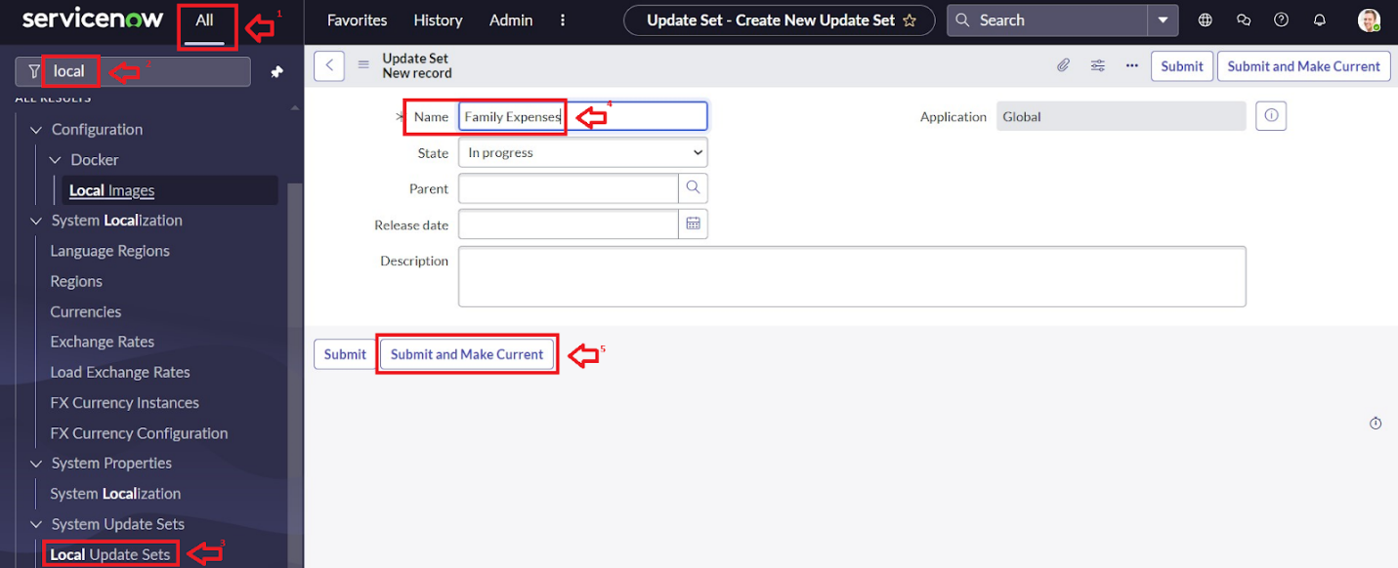

### **MILESTONE 3**

### **ACTIVITY 1:Creation of New Update Set**

1. Go to All >> In the filter search for Local Update set > click on New.



1. Enter the Details as:

Name : Family Expenses

1. Then click on Submit and Make current.



**MILESTONE 4**

**ACTIVITY 1:Creation of Family Expenses Table**

1. Go to All > In the filter search for Tables > click on New.
2. Enter the Details:

Label : Family Expenses

Name : Auto-Populated

New menu name : Family Expenditure

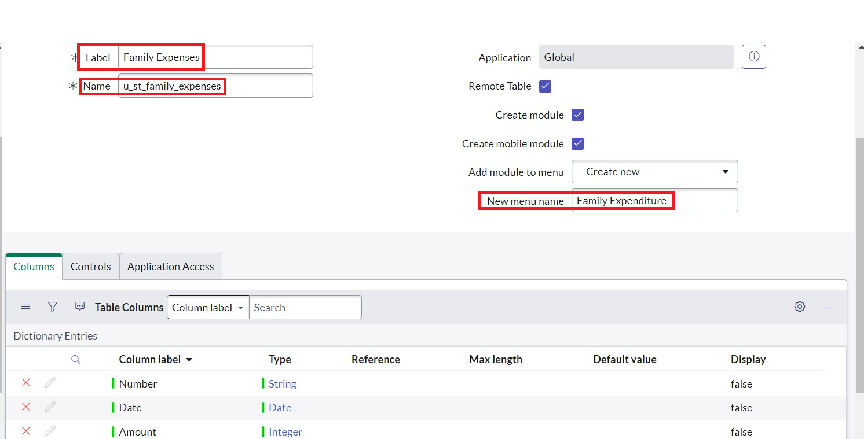

**ACTIVITY 2:Creation of Columns(Fields)**

1. Near Columns Double click near insert a new row.
2. Give the details as:

Column label : Number

Type : String

1. Double click on insert a new row again
2. Give the details as:

Column label : Date

Type : Date

1. Double click on insert a new row again
2. Give the details as:

Column label : Amount

Type : Integer

1. Double click on insert a new row again
2. Give the details as:

Column label : Expense Details

Type : String

Max length : 800

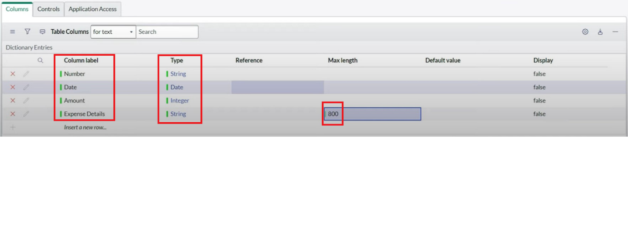

1. Go to the Header and right click there>> click on Save.

**ACTIVITY 3:Making Number Field an Auto-Number**

1. Double click on the Number Field/Column.
2. Go down and double click on Advanced view
3. In Default Value:

Use dynamic default : check the box

Dynamic default value : Get Next Padded Number

1. Click on Update.
2. 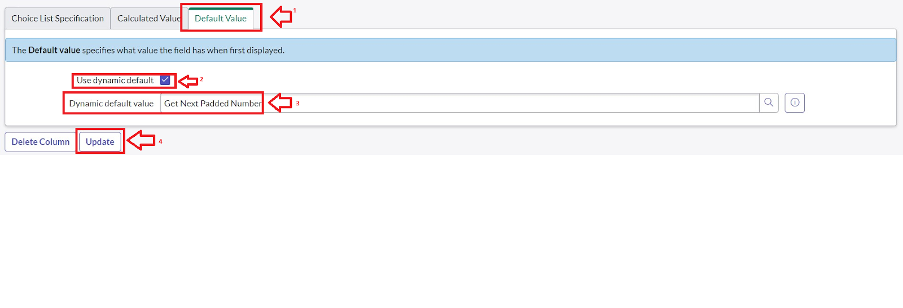
3. Go to All >> In the filter search for Number Maintenance >> select Number Maintenance
4. Click on New.
5. Enter the below Details:

Table : Family Expenses

Prefix : MFE

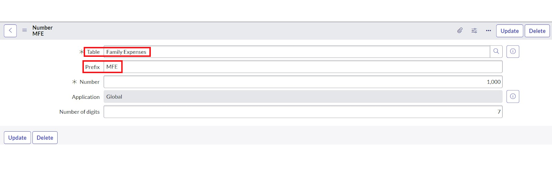

1. Click on Submit.

**ACTIVITY 4: Configure the Form**

1. Go to All >> In the filter search for Family Expenses >> Open Family Expenses
2. Click on New
3. Go to the Header and right click there>> click on Configure >> Select Form Design
4. Customize or Drag Drop the form as per your requirement.

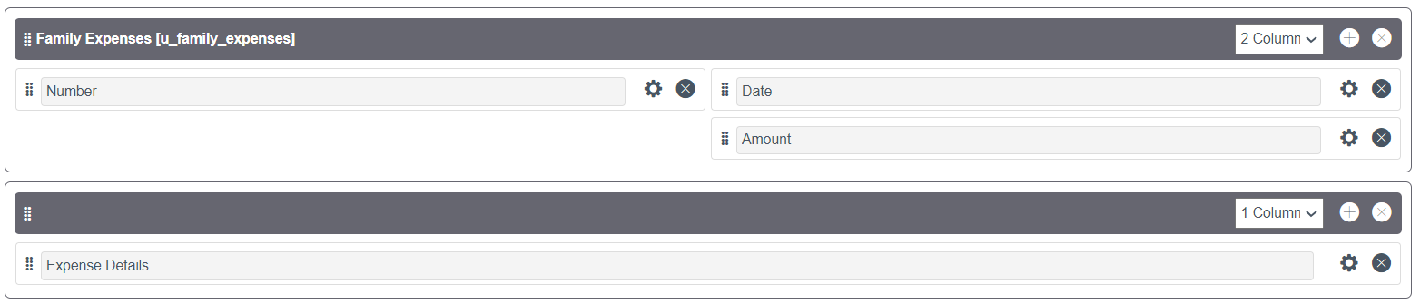

1. Make Number Read-Only Field by clicking on the gear icon and checking Read-Only
2. Make Date, Amount Mandatory Field by clicking on the gear icon and checking Mandatory
3. Click on Save.

**MILESTONE 5**

**ACTIVITY 1: Creation of Daily Expenses Table**

1. Go to All > In the filter search for Tables > click on New.
2. Enter the Details:

Label : Daily Expenses

Name : Auto-Populated

Add Module to menu : Family Expenditure

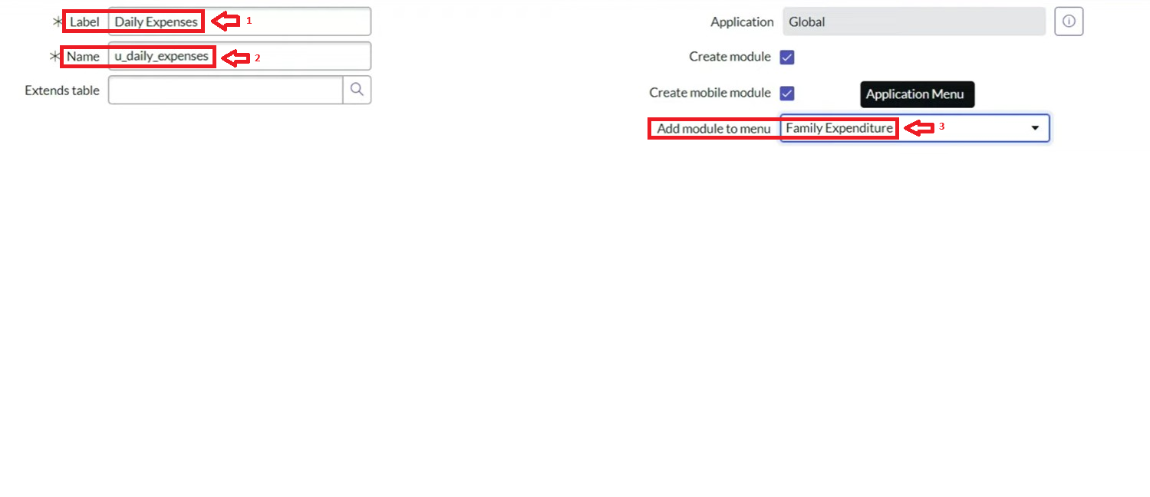

1. Go to the Header and right click there>> click on Save.

**ACTIVITY 2: Creation of Columns(Fields)**

1. Near Columns Double click near insert a new row.
2. Give the details as:

Column label : Number

Type : String

1. Double click on insert a new row again
2. Give the details as:

Column label : Date

Type : Date

1. Double click on insert a new row again
2. Give the details as:

Column label : Expense

Type : Integer

1. Double click on insert a new row again
2. Give the details as:

Column label : Family Member Name

Type : Reference

Max length : 800

1. Double click on insert a new row again
2. Give the details as:

Column label : Comments

Type : String

Max length : 800

1. Go to the Header and right click there>> click on Save.

**ACTIVITY 3: Making Number Field an Auto-Number**

1. Double click on the Number Field/Column.
2. Go down and double click on Advanced view
3. In Default Value:

Use dynamic default : check the box

Dynamic default value : Get Next Padded Number

1. Click on Update.
2. 
3. Go to All >> In the filter search for Number Maintenance >> select Number Maintenance
4. Click on New.
5. Enter the below Details:

Table : Family Expenses

Prefix : MFE

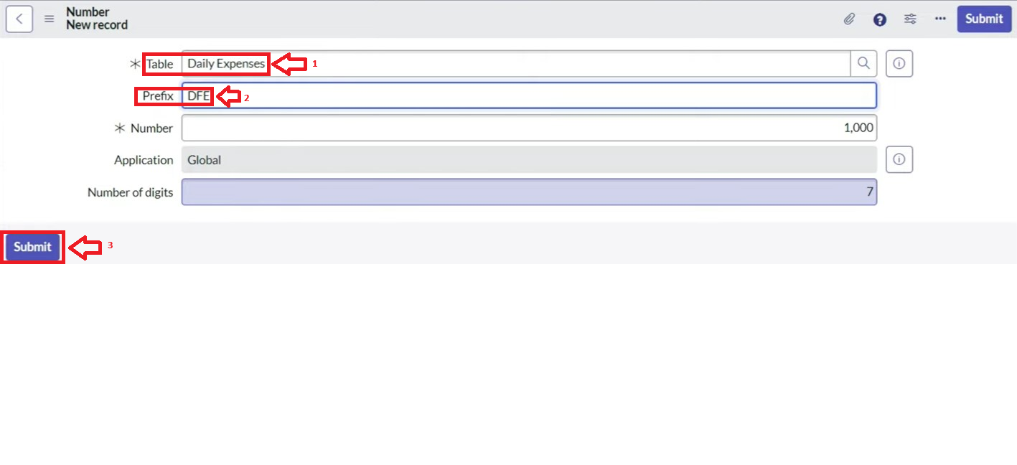

1. Click on Submit.

**ACTIVITY 4: Configure the Form**

1. Go to All >> In the filter search for Daily Expenses >> Open Daily Expenses
2. Click on New
3. Go to the Header and right click there>> click on Configure >> Select Form Design
4. Customize or Drag Drop the form as per your requirement.

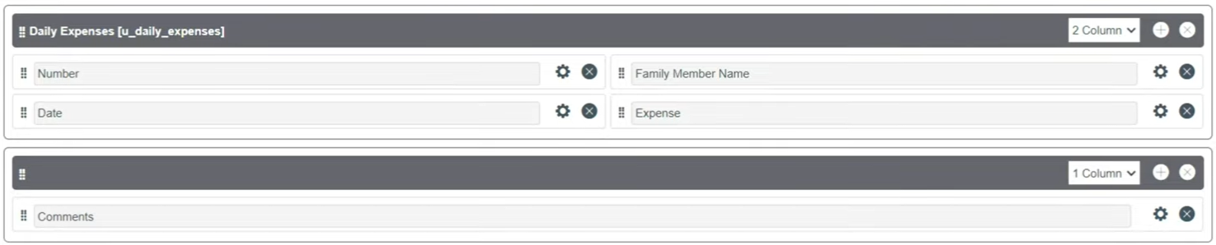

1. Make Number Read-Only Field by clicking on the gear icon and checking Read-Only
2. Make Date, Family Member Name Mandatory Field by clicking on the gear icon and checking Mandatory
3. Click on Save.

**MILESTONE 6**

**ACTIVITY 1: Creation of Relationship between Family Expenses and Daily Expenses tables**

1. Go to All >> In the filter search for Relationships >> Open Relationships
2. Click on New.
3. Enter the details:

Name : Daily Expenses

Applies to table : Select Family Expenses

Daily Expenses : Select Daily Expenses

1. Click Save.

**MILESTONE 7**

1. **ACTIVITY 1: Configuring Related List on Family Expenses**Go to All >> In the filter search for Family Expenses >> Open Family Expenses
2. Click on New
3. Go to the Header and right click there>> click on Configure >> Select Related Lists
4. Add Daily Expenses to the Selected Area.
5. Click on Save

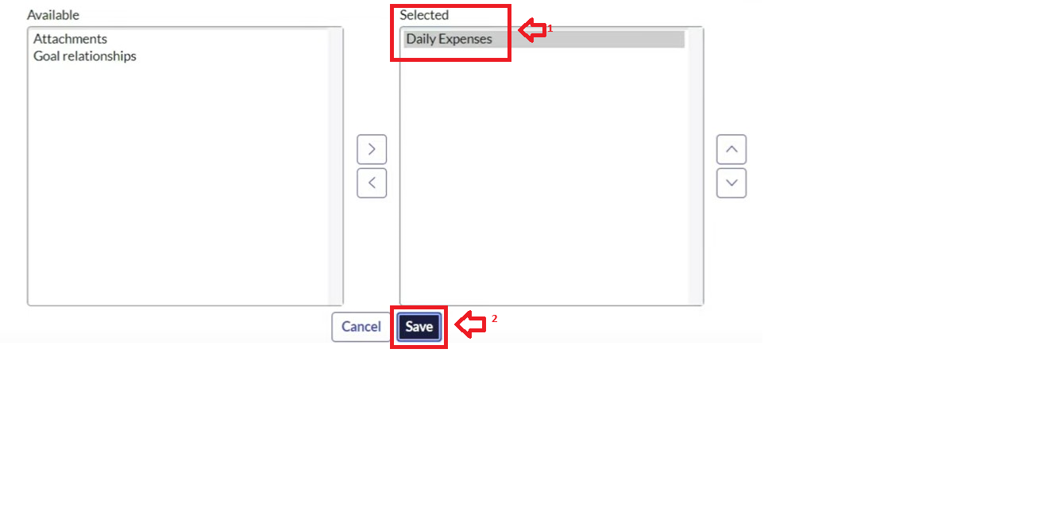

**MILESTONE 8**

**ACTIVITY 1: Creation of Business Rules**

1. Go to All >> In the filter search for Business Rules.
2. Under System Definition Select Business Rules then click on New.
3. Enter the Details:

Name : Family Expenses BR

Table : Select Daily Expenses

Check Advanced

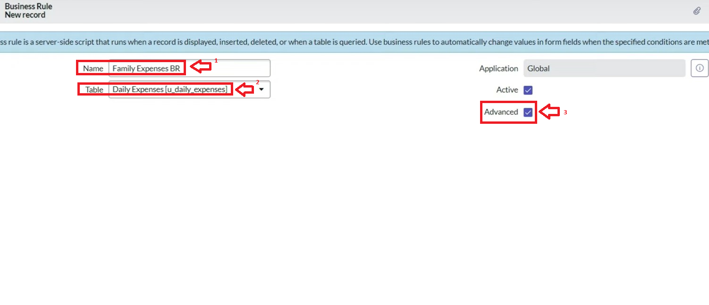

1. In when to run Check Insert and Update

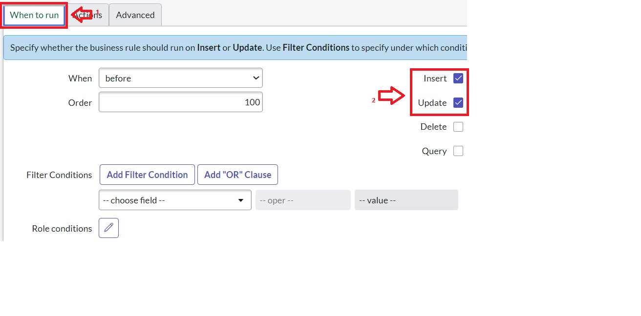

1. In Advance(we write the code): Write the below code >>

(function executeRule(current, previous /*null when async*/) {

var FamilyExpenses = new GlideRecord('u_family_expenses');

FamilyExpenses.addQuery('u_date',current.u_date);

FamilyExpenses.query();

if(FamilyExpenses.next())

{

FamilyExpenses.u_amount += current.u_expense;

FamilyExpenses.u_expense_details += ">"+current.u_comments+":"+"Rs."+current.u_expense+"/-";

FamilyExpenses.update();

}

else

{

var NewFamilyExpenses = new GlideRecord('u_family_expenses');

NewFamilyExpenses.u_date = current.u_date;

NewFamilyExpenses.u_amount = current.u_expense;

NewFamilyExpenses.u_expense_details += ">"+current.u_comments+":"+"Rs."+current.u_expense+"/-";

NewFamilyExpenses.insert();

}

})(current, previous);

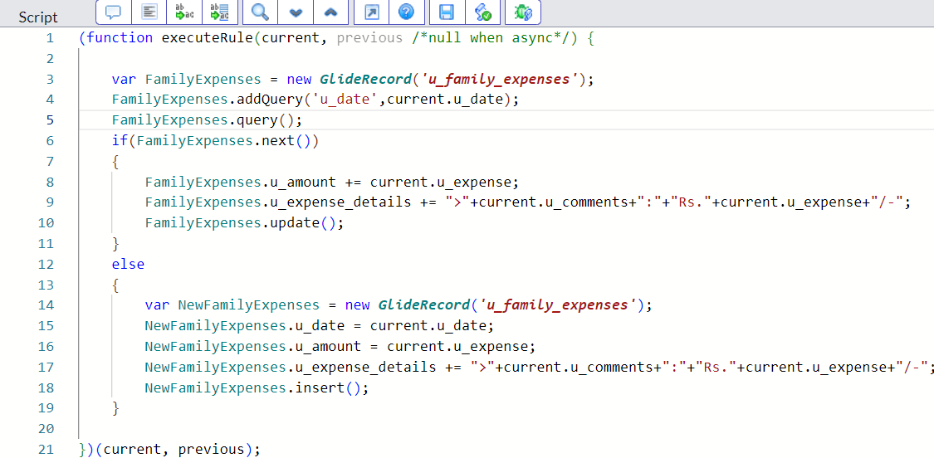

1. Go to the Header and right click there>> click on Save.

**MILESTONE 9**

**ACTIVITY 1: Configure the Relationship**

1. Go to All >> In the filter search for Relationships >> Open Relationships.
2. In that, open Daily Expenses Relationship.
3. For Applies to table : Select Family Expenses.
4. In Query with : write the below Query.

(function refineQuery(current, parent) {

// Add your code here, such as current.addQuery(field, value);

current.addQuery('u_date',parent.u_date);

current.query();

})(current, parent);

1. Click on Update.

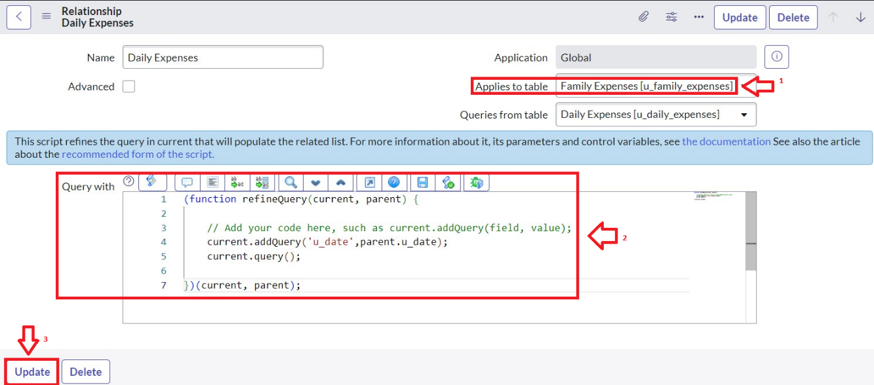

### **Conclusion:**